Here are **7 audit-ready Architectural Best Practices** specifically for the **Cloud AI Platform CoE** under the Microsoft Frontier Distribution Designation. These are mature, production-grade guidelines aligned with the requirement for "architectural best practices" in the centralized repository (as part of the evidence for CoE components: reusable assets, reference architectures, and technical documentation). They draw directly from Microsoft’s Well-Architected Framework for AI, Azure AI Architecture Center, Azure AI Foundry, and related guidance (e.g., secure, scalable, responsible, observable GenAI deployments).

Each best practice includes:
- **ID/Version** for governance (quarterly review recommended)
- **Description & Rationale** (why it's critical for enterprise-scale AI, partner enablement, and audit compliance)
- **Key Implementation Guidelines**
- **Security/Compliance Notes**
- **Architecture Diagram** (official or closely aligned Microsoft visuals for live demo)
- **References** (Microsoft Learn links for credibility)

Upload these to your repo with the diagrams (Visio/PNG exports), version history, and links to related playbooks/frameworks (e.g., RAG, Agents). For audit: Demonstrate searchable repo with these as standalone assets, showing relevance across regions.

### 1. Secure Network Isolation with Private Endpoints and VNet Integration
**Best Practice ID:** COE-CAI-ABP-001 | **Version:** 1.0 | **Last Updated:** Feb 2026

**Description & Rationale:** All Azure AI resources (OpenAI, AI Search, Foundry) must use private endpoints and VNet integration to eliminate public internet exposure, enforce least-privilege access, and ensure data sovereignty/compliance (e.g., GDPR, sovereign clouds). This is foundational for enterprise trust and avoids exfiltration risks in multi-tenant partner ecosystems.

**Key Implementation Guidelines:**
- Deploy AI services in customer VNets or hub-spoke topologies.
- Use managed private endpoints for AI Search, OpenAI, and Foundry.
- Integrate with Azure Firewall, NSGs, and Private DNS Zones for resolution.
- Enable service endpoints only where private not available.

**Security/Compliance Notes:** Managed identities only; RBAC + Just-In-Time access; audit logs to Azure Monitor; align with Azure Security Baseline for AI.

**Architecture Diagram:**
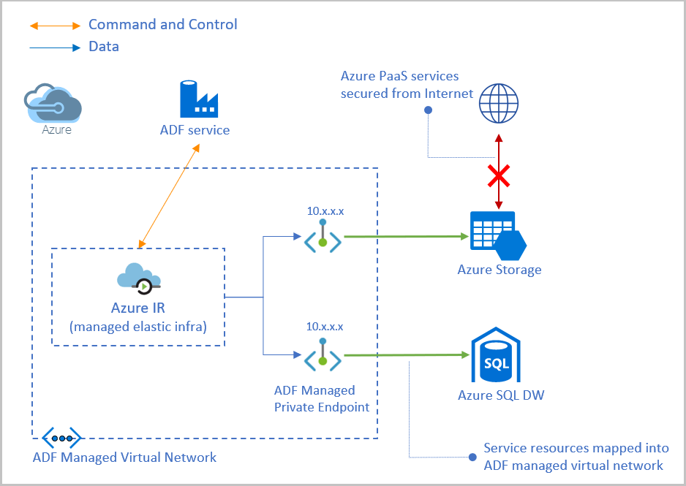

**References:** learn.microsoft.com/en-us/azure/virtual-network/vnet-integration-for-azure-services; Azure Private Link for AI services.

### 2. Optimized Retrieval with Hybrid Vector + Semantic Search in RAG
**Best Practice ID:** COE-CAI-ABP-002 | **Version:** 1.0

**Description & Rationale:** For grounded GenAI, use Azure AI Search hybrid (vector + keyword) with semantic reranking to maximize recall/precision, reduce hallucinations, and improve response quality. This is essential for production RAG apps and partner delivery acceleration.

**Key Implementation Guidelines:**
- Enable integrated vectorization for ingestion-time embeddings.
- Configure hybrid search (60% vector, 40% keyword) + semantic reranker.
- Use chunking (500-1000 tokens) with overlap and metadata filtering.
- Evaluate with RAG metrics (groundedness >85%).

**Security/Compliance Notes:** Private endpoints for indexes; content filters on queries/responses; data residency controls.

**Architecture Diagram:**

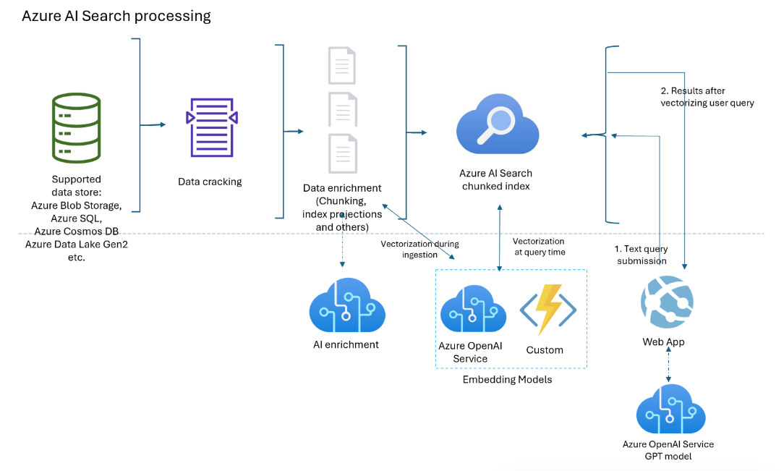

**References:** learn.microsoft.com/en-us/azure/search/vector-search-integrated-vectorization; RAG design guide.

### 3. Managed Agent Orchestration with Azure AI Foundry
**Best Practice ID:** COE-CAI-ABP-003 | **Version:** 1.0

**Description & Rationale:** Use Azure AI Foundry Agent Service for managed orchestration, thread management, and network isolation in single/multi-agent systems. This enables scalable, secure autonomous workflows while reducing custom code complexity for resellers.

**Key Implementation Guidelines:**
- Define agents with tools/knowledge (e.g., AI Search, Functions).
- Implement supervisor patterns for multi-agent coordination.
- Use managed threads and OBO auth for secure integrations.
- Incorporate observability (tracing, evaluation).

**Security/Compliance Notes:** Network isolation; content safety filters; agent-level RBAC; audit trails.

**Architecture Diagram:**
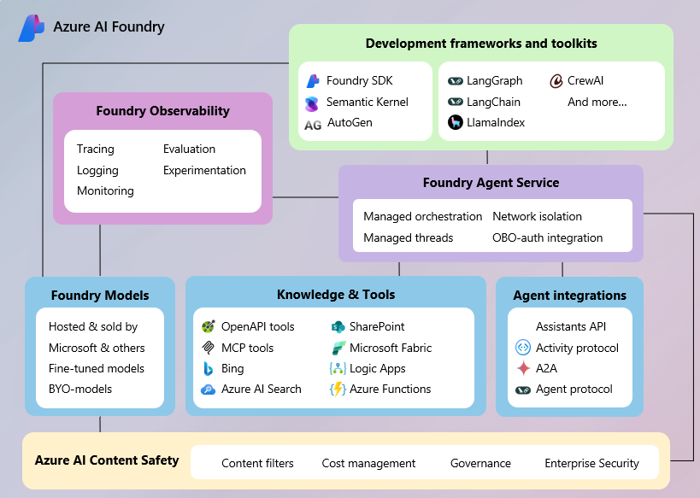

**References:** learn.microsoft.com/en-us/azure/ai-foundry/agents/overview; Foundry Agent Service docs.

### 4. Embedded Responsible AI Governance and Safety Controls
**Best Practice ID:** COE-CAI-ABP-004 | **Version:** 1.0

**Description & Rationale:** Integrate Responsible AI tools (e.g., Content Safety, dashboard) throughout the lifecycle to assess fairness, mitigate harm, and ensure transparency/accountability—critical for regulatory compliance and trust in AI deployments.

**Key Implementation Guidelines:**
- Apply Content Safety filters at input/output.
- Use Responsible AI Dashboard for bias/error analysis.
- Conduct impact assessments and red teaming.
- Monitor production for drift/harmful content.

**Security/Compliance Notes:** Align with Microsoft Responsible AI Standard; human-in-the-loop for high-risk scenarios; logging for audits.

**Architecture Diagram:**
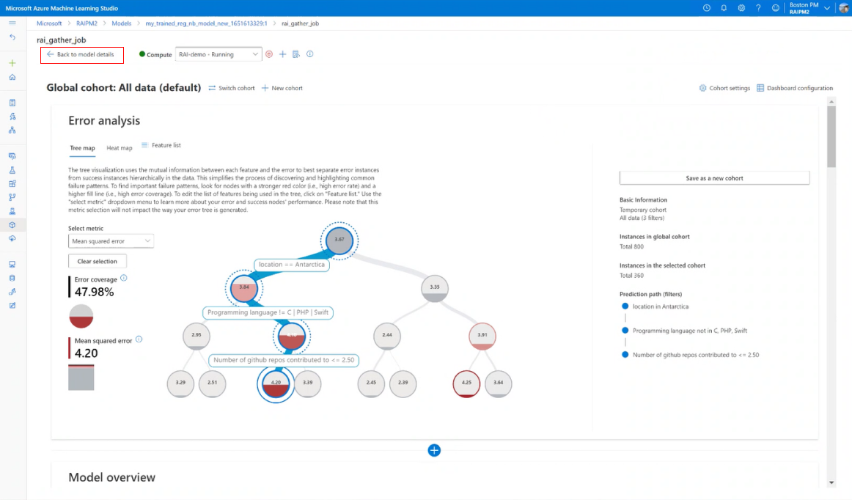

**References:** learn.microsoft.com/en-us/azure/machine-learning/concept-responsible-ai-dashboard; Responsible AI playbook.

### 5. Comprehensive Observability with Azure Monitor
**Best Practice ID:** COE-CAI-ABP-005 | **Version:** 1.0

**Description & Rationale:** Centralize telemetry (metrics, logs, traces) from AI workloads into Azure Monitor for real-time insights, alerting, and troubleshooting—enables proactive issue resolution and performance optimization across partner ecosystems.

**Key Implementation Guidelines:**
- Enable diagnostic settings on all AI resources.
- Use Log Analytics workspaces (dedicated if needed) + Application Insights.
- Create custom dashboards/alerts for token usage, latency, drift.
- Integrate with SIEM for enterprise-wide visibility.

**Security/Compliance Notes:** Data encryption; retention policies; access controls on workspaces.

**Architecture Diagram:**

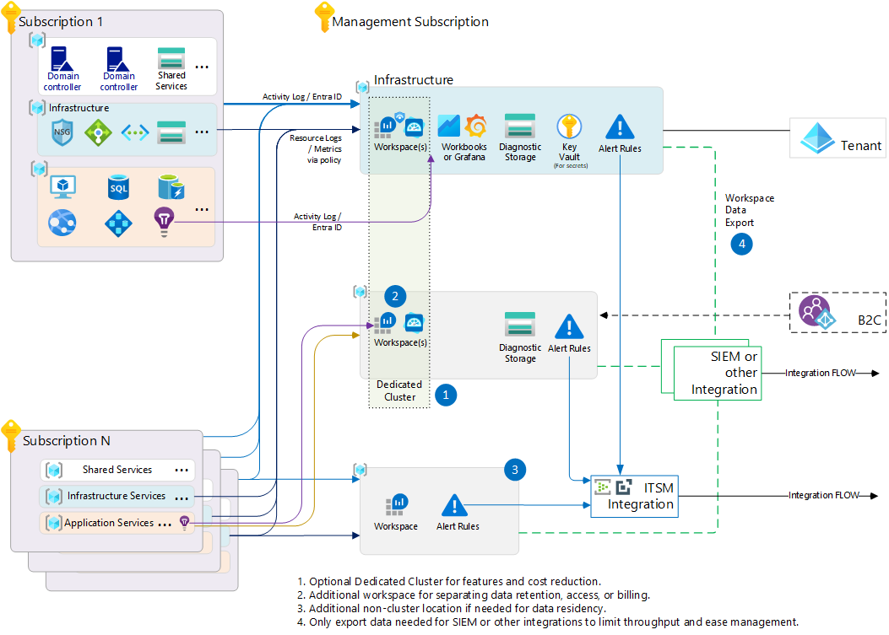

**References:** learn.microsoft.com/en-us/azure/azure-monitor/fundamentals/enterprise-monitoring-architecture.

### 6. Multi-Region High Availability and Disaster Recovery
**Best Practice ID:** COE-CAI-ABP-006 | **Version:** 1.0

**Description & Rationale:** Design AI applications for zonal/multi-region redundancy with geo-replication, automated failover, and data synchronization to minimize downtime and meet enterprise SLAs (e.g., 99.99% availability).

**Key Implementation Guidelines:**
- Use zone-redundant services (AI Search, OpenAI PTUs).
- Implement Traffic Manager or Front Door for failover.
- Replicate indexes/data (e.g., Cosmos DB geo-redundancy).
- Test DR runbooks quarterly.

**Security/Compliance Notes:** Private peering across regions; encryption in transit/rest; compliance with data residency.

**Architecture Diagram:**

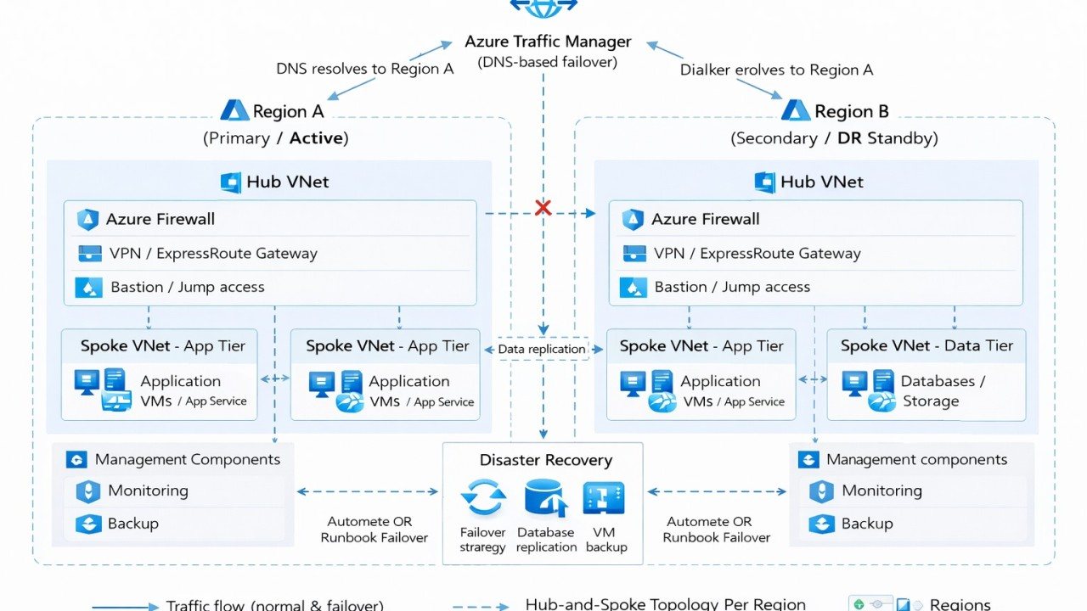

**References:** Azure Architecture Center multi-region BCDR patterns.

### 7. Cost Optimization with Provisioned Throughput Units (PTUs)
**Best Practice ID:** COE-CAI-ABP-007 | **Version:** 1.0

**Description & Rationale:** Use PTUs for predictable performance/cost in high-volume AI workloads, combined with monitoring and auto-scaling policies, to control spend while ensuring capacity—vital for partner ROI and sustainable growth.

**Key Implementation Guidelines:**
- Provision PTUs for Azure OpenAI models (e.g., GPT-4o).
- Monitor hourly billing and adjust deployments dynamically.
- Implement caching, query optimization, and token-efficient prompts.
- Use Azure Cost Management alerts/reports.

**Security/Compliance Notes:** Quotas via GenAI Gateway; no impact on data privacy.

**Architecture Diagram:**

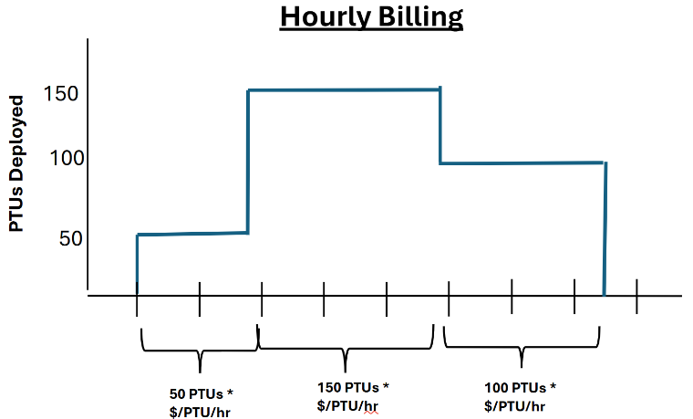

**References:** learn.microsoft.com/en-us/azure/ai-foundry/openai/how-to/provisioned-throughput-onboarding.

These best practices are concise yet comprehensive for audit evidence—demonstrate them in the live repo demo showing diagrams, updates, and cross-references to playbooks/frameworks. If you'd like expansions (e.g., Bicep snippets, evaluation checklists), or similar for other CoEs, let me know your priority!

